1. 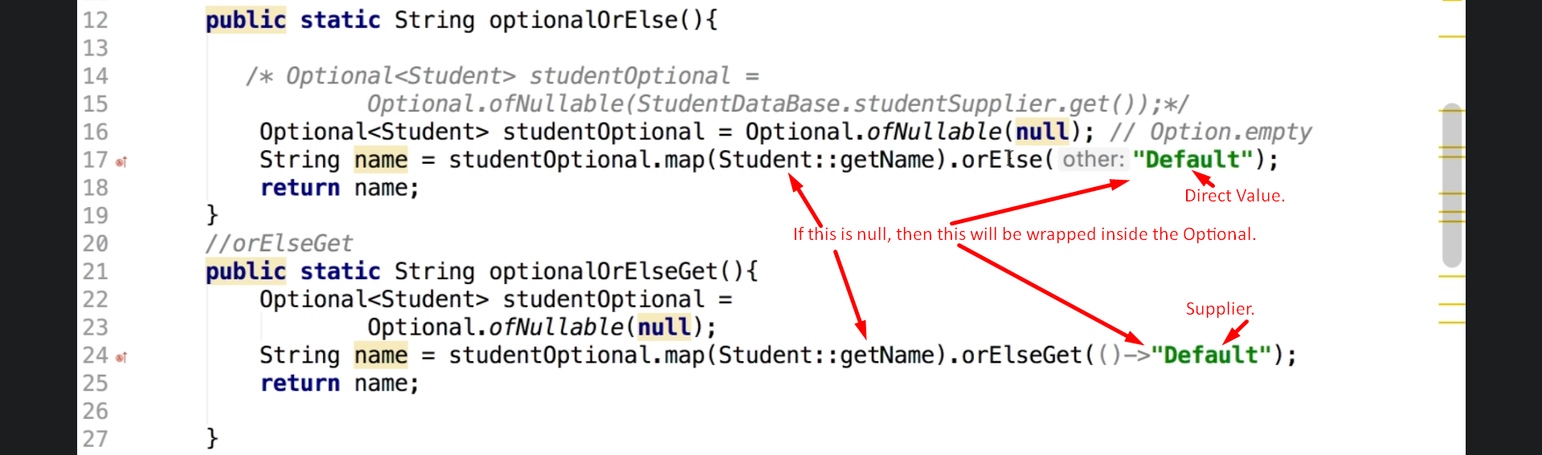**NOTE**: Let’s take a look at the map(mapper) implementation.  
   
2. 